**Project Proposal**

**on**

**Student Billing System**



**Tribhuvan University**

**Faculty of Humanities and Social Sciences**

**Bachelors in Computer Application**

**Submitted to**

**Department of Computer Application**

**Padmashree International College**

**Tinkune, Kathmandu**

|  |  |
| --- | --- |
| **Submitted by** | |
| KHESEHANG YONGHANG | KRISHNA DEV SAH |
| Year/Sem :- 2079 / Fourth Semester | Year/Sem :- 2079 / Fourth Semester |
| University Registration Number | University Registration Number |
| 6-2-22-324-2018 | 6-2-22-339-2018 |
| Exam Roll Number :- 220118 | Exam Roll Number :- 220133 |

# **Table of Contents**

**Table of Contents** **3**

**List Of Figures** **4**

**Introduction** **1**

**Problem Statement** **1**

**Objectives** **1**

**Scope** **1**

**Methodology** **1**

a) **Requirement Identification** **1**

i) **Literature Review** **1**

ii) **Requirements Collection** **2**

b) **Feasibility Study** **3**

i) **Technical Feasibility** **3**

ii) **Operational Feasibility** **3**

iii) **Economic Feasibility** **3**

iv) **Schedule Feasibility** **4**

c) **High level Design of system** **4**

i) **System Analysis and Design** **4**

ii) **System Development Tools** **7**

**Expected Outcome** **8**

References 13

# **List Of Figures**

**Figure 1: Gantt chart for Student Billing System** 4

**Figure 2: Entity Relational Diagram for Student Billing System** 5

**Figure 3: level 0 DFD for Billing Management System** 6

**Figure 4: Level 1 DFD for Billing Management System** 7

**Figure 5: Mockups for Student Billing System** 9

# **Introduction**

Student Billing System (SBS) is a web-based application system, which will allow a greater student accounting experience. This application will allow to automate and digitalize all student account data, including payment, account management, and bill generation. SBS should be used by students to pay semester fees and view their remaining fees. The main aim of this system is to enable a smooth experience to all both students and account staffs.

A system database will store all the mentioned details and information about the college accounting side and the students.

# **Problem Statement**

In Nepal, most of the governmental and even private educational institutions have a hard time providing a detailed information about the fees and associated expenses to the students, creating confusion to the students as well as their parents. Furthermore, it makes it hard to organize the student accounts.

# **Objectives**

This system will provide solutions to the problems faced by the students studying all around Nepal. Some of the objectives are:

* To provide the methods of accessing the fee accounts to the students.
* To allow college to manage student accounts with more transparency.
* To provide the overall view of the student college fee to the students.

# **Scope**

The system is aimed at colleges and other educational institutions. Students and the accounting staffs of the college will have access to the system.

# **Methodology**

## **Requirement Identification**

### **Literature Review**

There are a few existing systems on the proposed system. Though the exact implementation isn’t there in the web, however a few similar systems are in existence. Freshworks is a tool that helps helps business owners to manage multiple sales, marketing, and customer support processes. According to its website, the organization provides a web-based solution for handling finances of its clients. Besides that, it provides many other features. [2]

Likewise, Sales Cloud also provides the feature of Sales Pipeline Management and account contact management, out of its other features. [3]

### **Requirements Collection**

We decided to divide the requirements for this system in two different terms, one functional and another non-functional.

* **Functional Requirements.**

**For Students:**

* The system should allow students to login.
* The system should display what faculty and semester they belong.
* It should display the due amount to be paid and the overall fee structure.

**For Accounting Staff:**

* The system should manage student username and password.
* The system should display in which semester the students are studying and the amount they need to pay.
* The system should allow staffs to update the student accounts.
* The system should allow bill generation.

**For System Administrator:**

* The system should allow the system administrator to login and logout from the system.
* The system should allow the system administrator to manage details and information of staffs and students.
* The system should allow monitoring the system users (students and staffs) data via logs.
* **Non- Functional Requirements.**

**Security**

Only the system admin has the right to the entire system. Other than him/her, students

and staffs must pass through an authentication procedure to access the subsystems.

**Availability**

The system will be available for 24 hours as students can access it from anywhere andat any time. However, the payment procedure will be dependent on whether the bank system is running or not.

**Performance**

It will handle any expected or unexpected errors and also large amounts of data.

**Reliability**

The system will be reliable as it performs all the other functional and non-functional features with minimum failure rate. Further, its reliability is a must as the data is important and damages can cause incorrect or incomplete student details.

## **Feasibility Study**

### **Technical Feasibility**

As for the technologies for the proposed project, they all fall under the basic programming languages. Likewise, the libraries used are well understood and studied till this semester. All the used technologies are well documented in the web and provide a good base for the development and maintenance of the system.

### **Operational Feasibility**

Regarding the operation of the system, it will include all the functional and non-functional requirements and under all circumstances be operational. Speaking about operability of the system, the features will be completely operational and the users will be comfortable to use this system.

### **Economic Feasibility**

The system is economically feasible as we aren’t buying any specific hardware and hosting platforms. Furthermore, all the used technological tools are open source.

### **Schedule Feasibility**

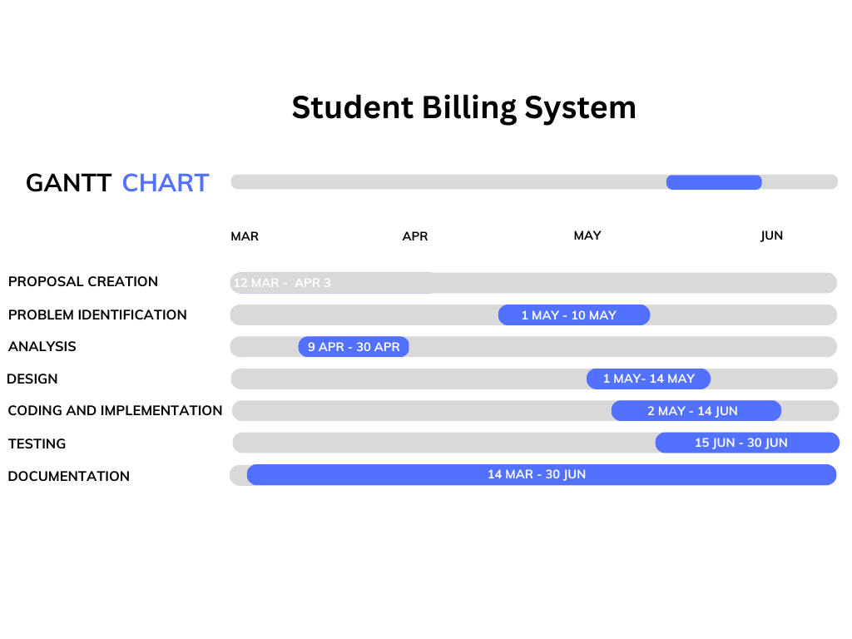The system which we are going to develop will be completed within scheduled time and will not exceed the scheduled time.

**Figure 1: Gantt chart for Student Billing System**

## **High level Design of system**

### **System Analysis and Design**

**Data Modeling (ER-Diagram)**

In Entity-Relationship diagram there are a few entities named administrator, student, and account staff. Admin has attributes like Admin id, name, password, email. Likewise, student has student id, name, password, email, phone, semester, and total college fee. 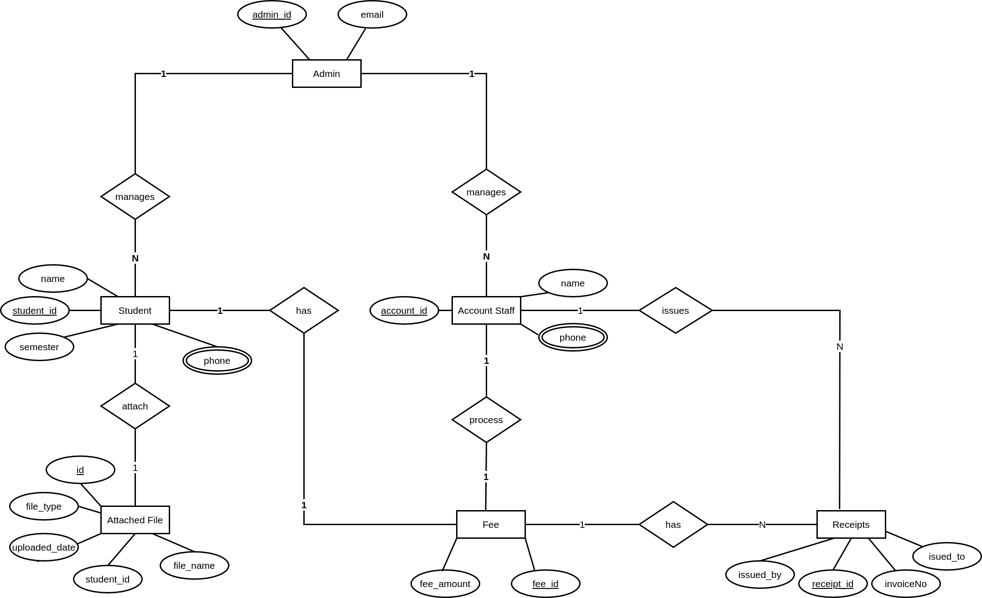Similarly, account staff has attributes like id, name, password, email, phone, and address.

**Figure 2: Entity Relational Diagram for Student Billing System**

**Process Modeling (DFD)**

Data Flow Diagram of Billing Management System consists of two levels of DFD, context diagram and level one DFD. Both these levels are used for making data flow diagram of BMS.

In context diagram, the login, register, and payment requests are the inputs of BMS where admin and staff request for login and student enquiry about their fee status and make payment. The login response and payment details are the outputs. Staff and students get response about login their login status.

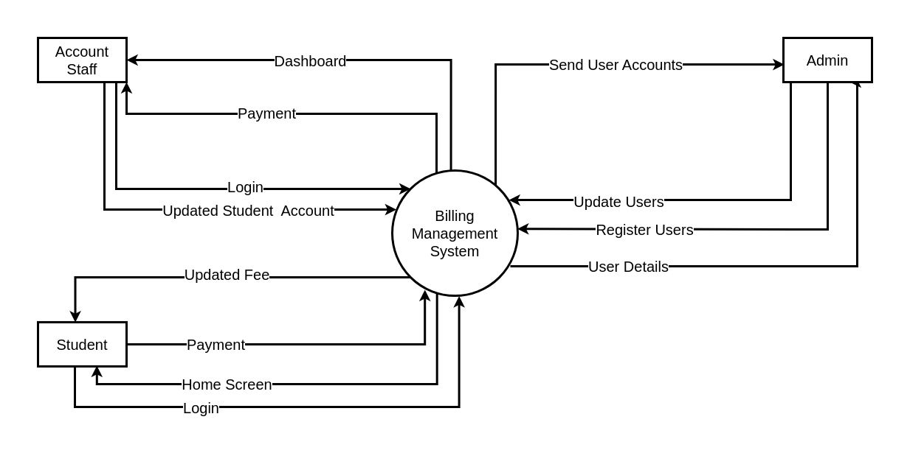

**Figure 3: level 0 DFD for Billing Management System**

In level 1 DFD, process 1 is for login, 2 is for fee payments handling, 3 is for updating students financial accounts, 4 is for modifying users. Admin, student, and account staff are the three entities and data stores for student fee details and staff details are used.

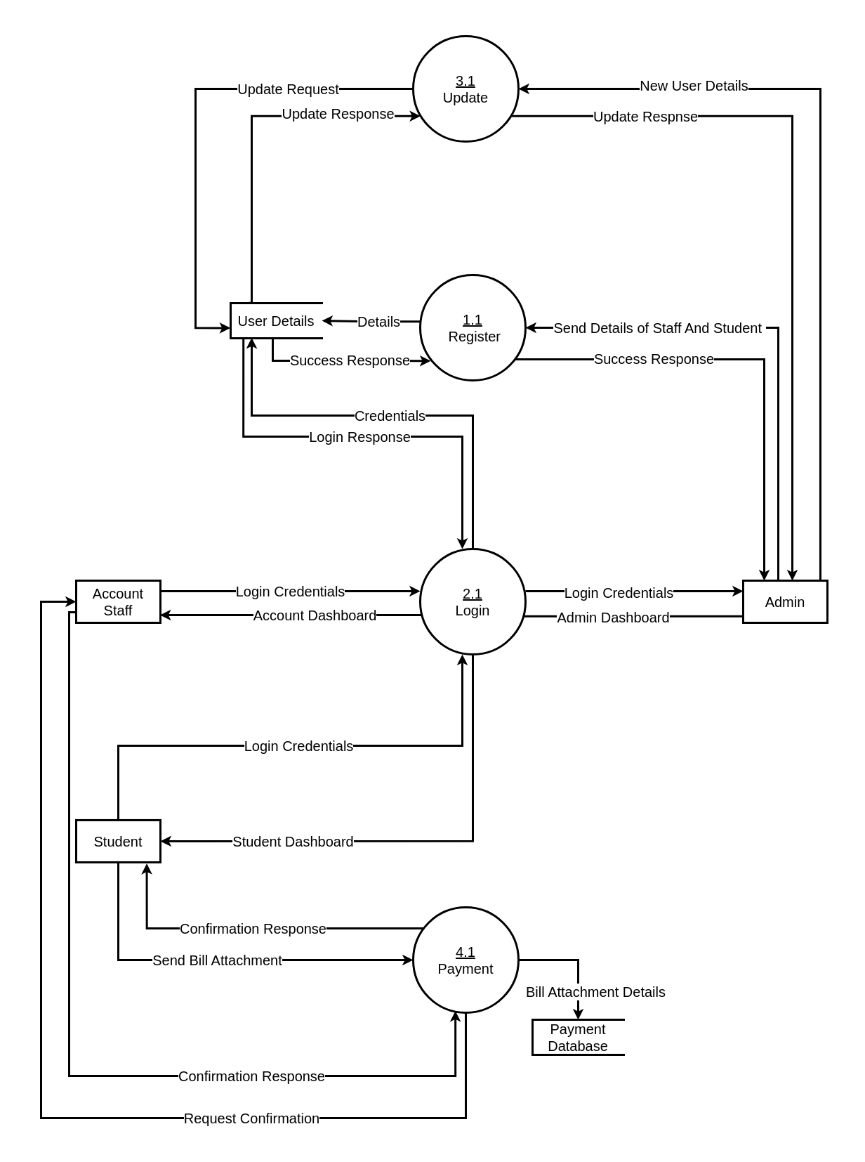

**Figure 4: Level 1 DFD for Billing Management System**

### **System Development Tools**

* **Implementation Tools**

**Front end**

* + 1. HTML (Hyper Text Markup Language)
    2. CSS (Cascading style sheet)
    3. JavaScript
    4. jQuery
    5. ReactJS

**Back end**

* + 1. NodeJS

**Database**

* + 1. MongoDB

**Diagrams**

* + 1. Figma
    2. draw.io
    3. Canva

# **Expected Outcome**

The successful completion of the project will enable students to make quick fee payments. This allows them to have a good transaction experience. Furthermore, they will be able to see their entire payment history, enabling them to have a good grasp of their due date.

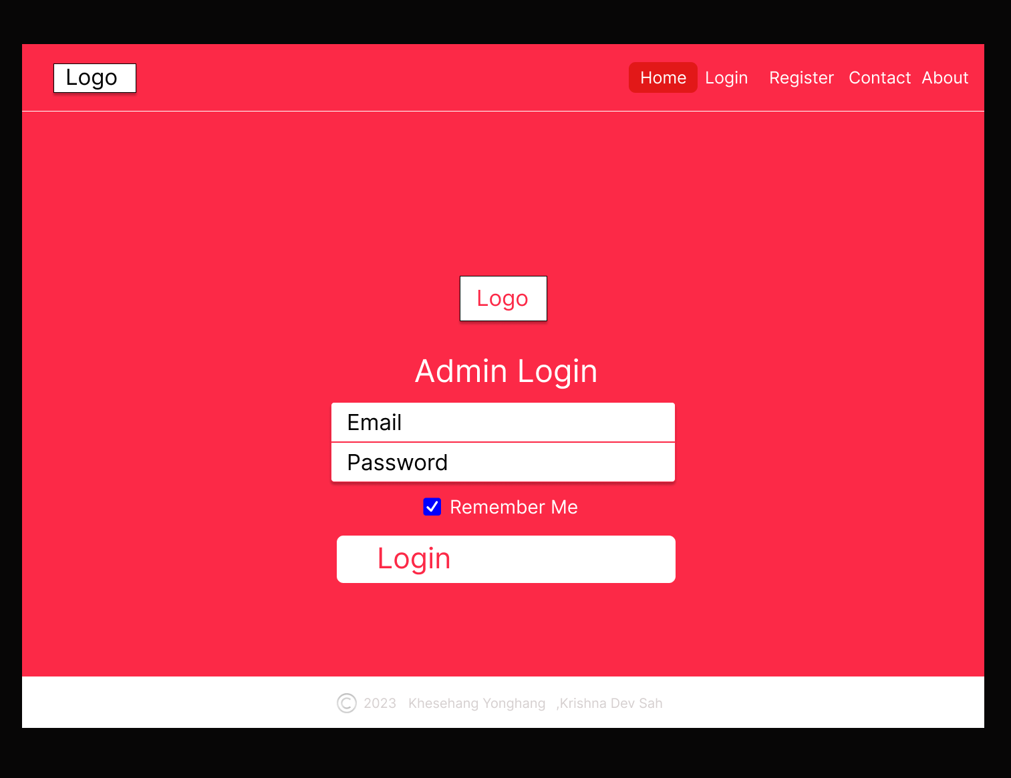**Figure 5: Mockups for Student Billing System**

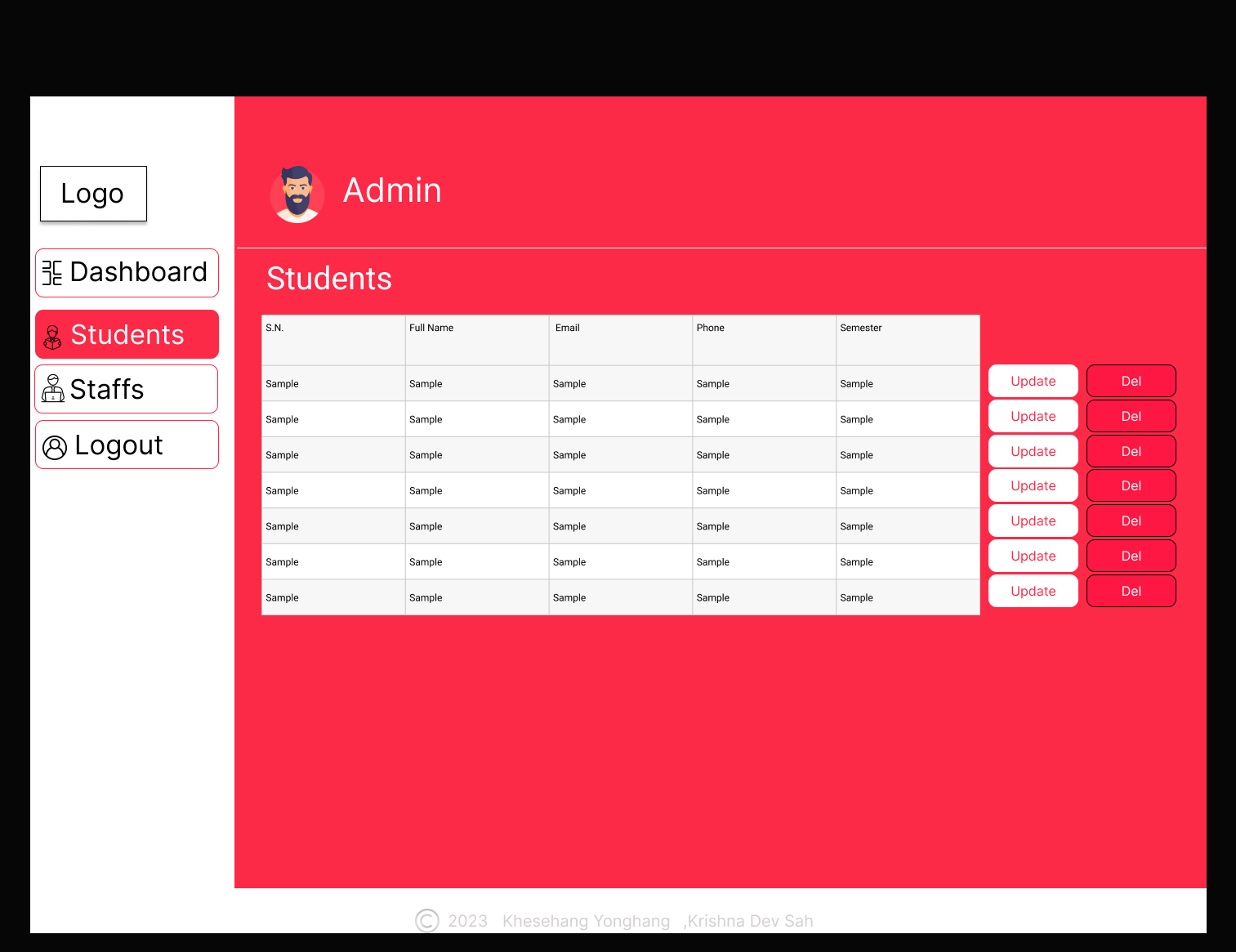

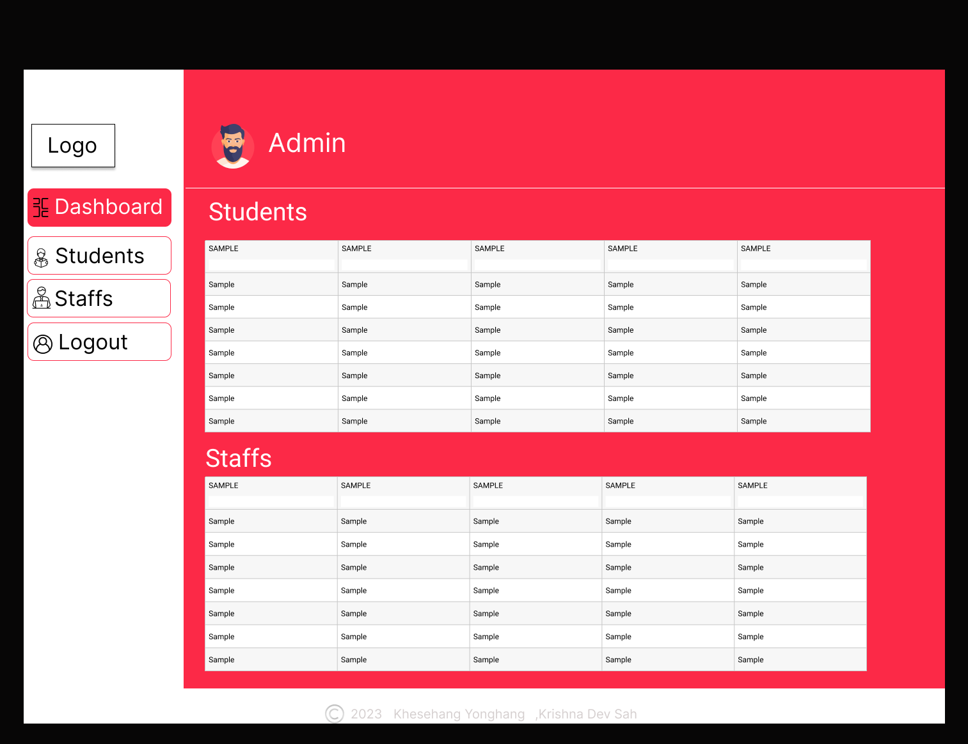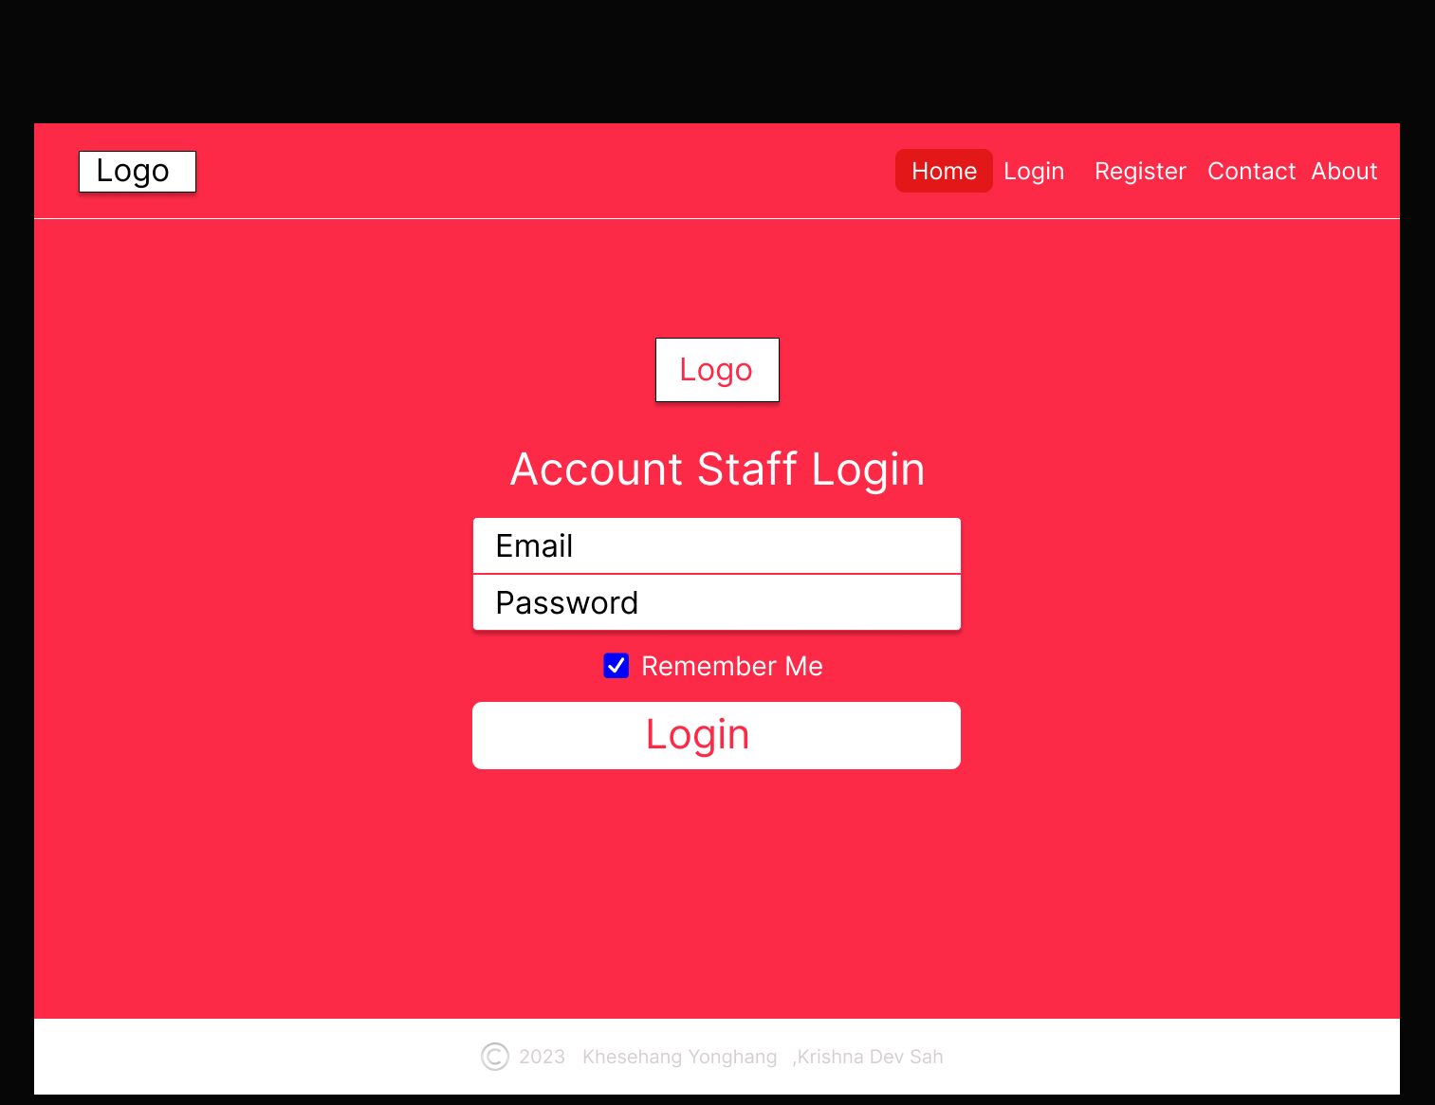

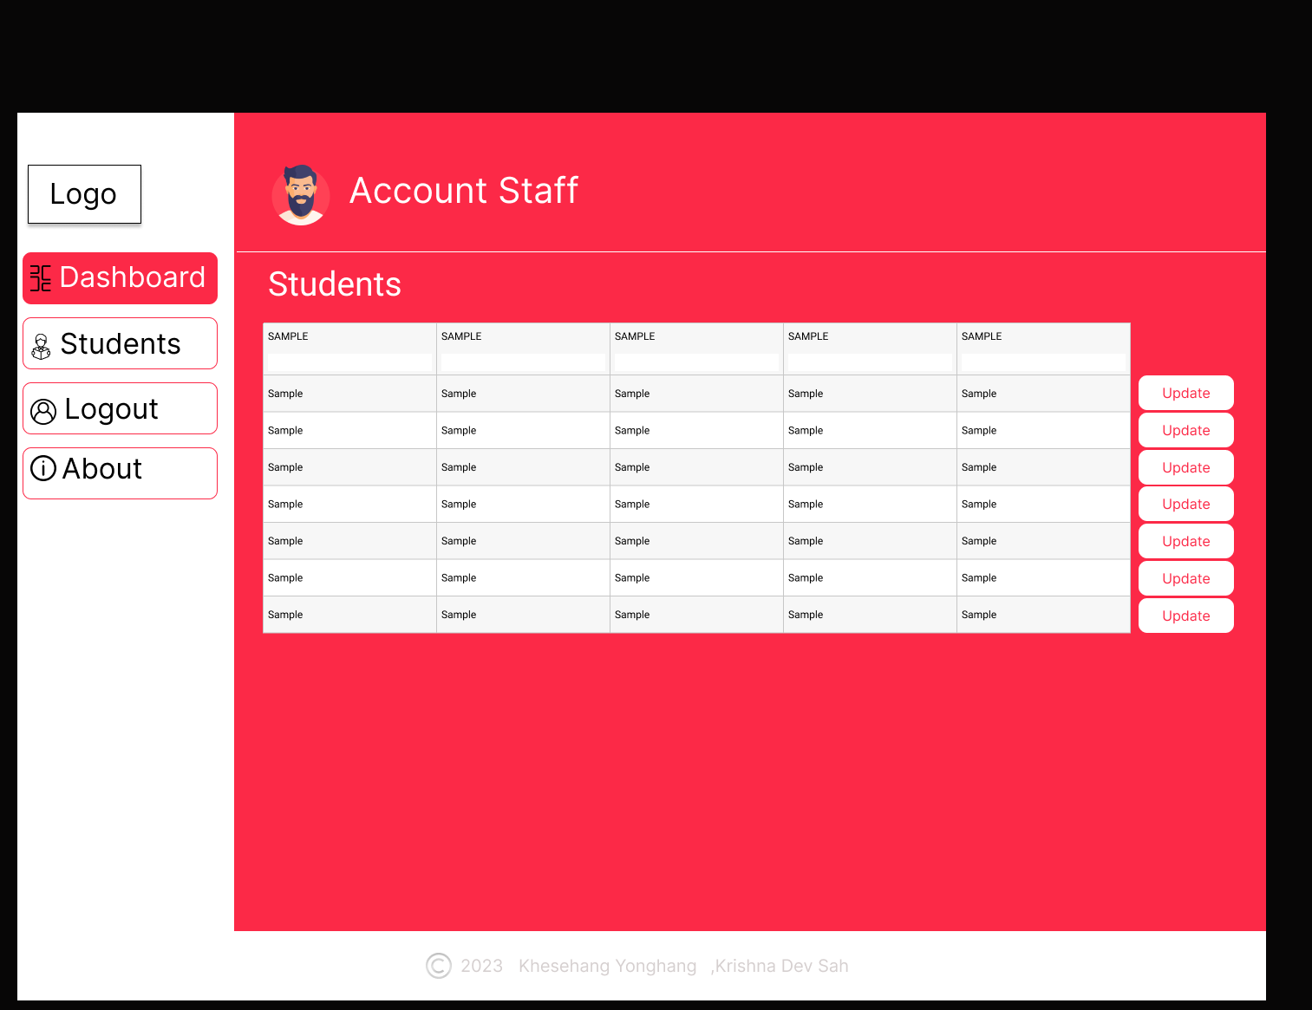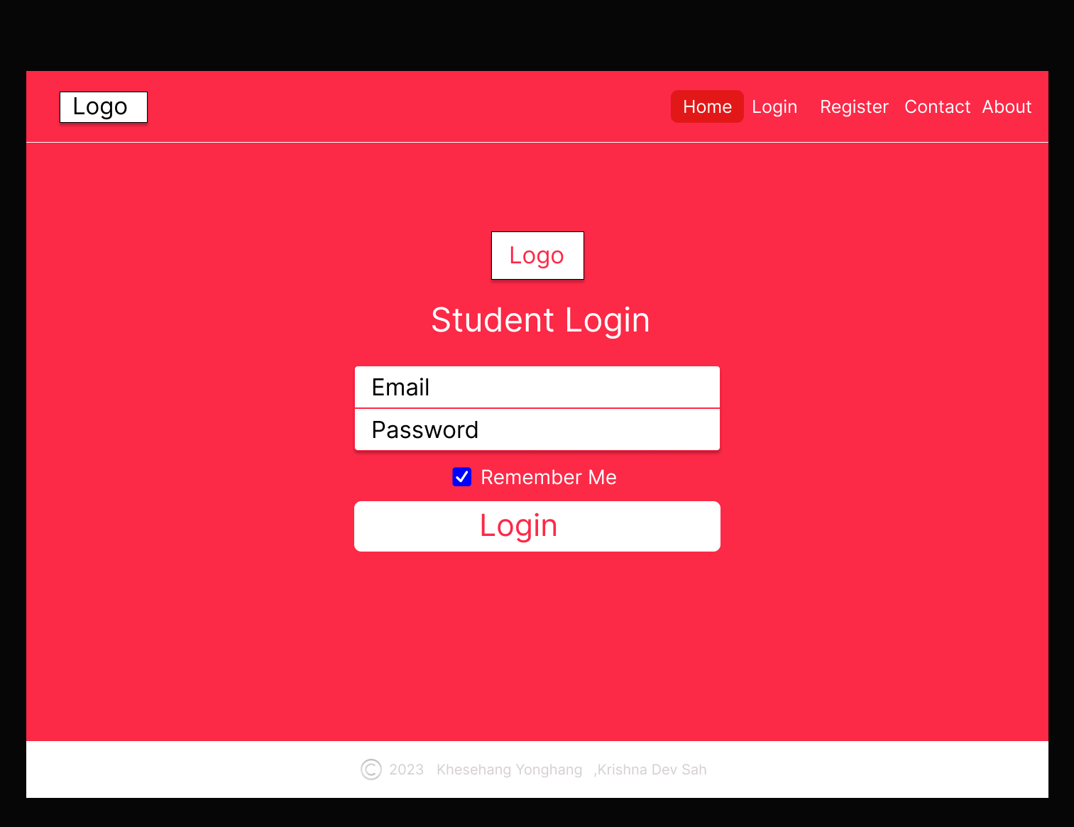

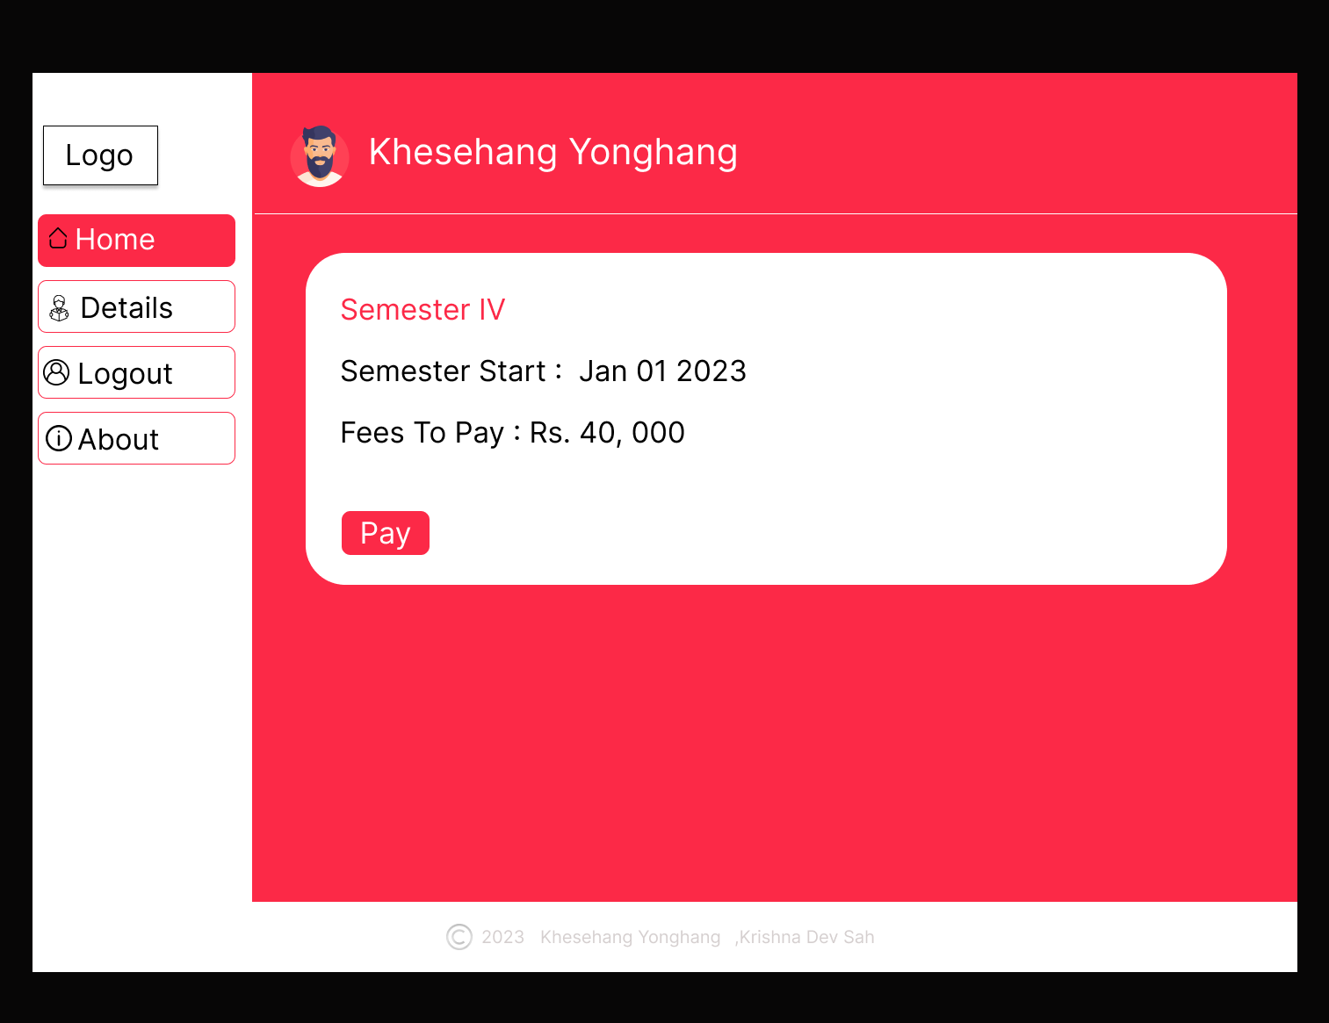

# **References**

|  |  |
| --- | --- |
| [1] | P. Solomon, "MERN Stack Invoicing Application," 2022. [Online]. Available: https://github.com/panshak/accountill. |
| [2] | "Freshworks," [Online]. Available: https://www.freshworks.com/products/. |
| [3] | "Sales Cloud," [Online]. Available: https://www.salesforce.com/products/sales-cloud/overview/. |
| [4] | "Zoho CRM," [Online]. Available: https://www.zoho.com/crm/. |
| [5] | "apm.org.uk," APM, [Online]. Available: https://www.apm.org.uk/resources/find-a-resource/gantt-chart/. |